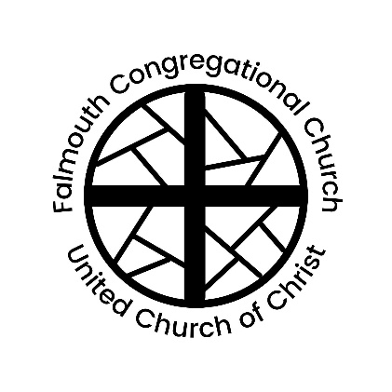
Falmouth Congregational Church
United Church of Christ
An Open and Affirming Congregation
The Reverend Amelia Edson
Serving Christ and Community since 1754

267 Falmouth Rd., Falmouth, ME, 04105 | 207-781-3413 | www.falmouthcongregationalchurch.org

10:00 AM REIGN OF CHRIST / THANKSGIVING SUNDAY November 20, 2022
THE COMMUNITY GATHERS
If you are new to worship, welcome and please fill out a blue visitor card.
Throughout the order of worship, if the print is in bold, words may be spoken in unison.

GATHERING MUSIC "Voluntary for Organ Duet"
(Based on Five Hymns of Praise) Charles Callahan
“Variations on
‘Praise to the Lord, the Almighty’” Michael Burkhardt
Jan Stover and Mark Thallander, Organ Duets

WELCOME & ANNOUNCEMENTS

THE PASSING OF THE PEACE (Please remain in your seat while passing the peace of Christ.)
One: May the peace of Christ be with you.
All: And also with you.

PRELUDE Medley: “Amazing Grace” arr. Fred Swann
and
“Hymn of Majesty and Praise” arr. Mark Thallander
Mark Thallander, Organ

FROM BREAD & CUP TO FAITH & GIVING

CALL TO WORSHIP
All: Breathe on me, Breath of God, fill me with life anew,
that I may love the way you love, and do what you would do.

CALL TO CONFESSION
One: O God, hear our confession of our sins.
All: We know that we are already rich; we have enough, more than many can imagine.
One: but too often we fall into the trap of wanting more
All: Even with our wealth, perhaps because of our wealth, we need help to live faithfully.
One: Forgive us, we pray. Lead us to live boldly as generous witnesses to the strength we have in Christ Jesus. Amen.

ASSURANCE OF PARDON
One: Friends, hear this Good News: the love of God is beyond measure, and you are included in that love. Know that you are forgiven and thus freed to love and serve.
All: Alleluia! Amen.

CHILDRENS MOMENT Mark Thallander

*HYMN “I Thank You, Jesus” No. 116

SCRIPTURE Acts 2:43-47 Nancy Lightbody

ALL-AGES INTERACTIVE SERMON Rev. Amelia Edson

*HYMN “Let All Things Now Living” No. 717

PRAYERS OF THE PEOPLE

THE LORD’S PRAYER

STEWARDSHIP MOMENT Mark Howison

THE OFFERTORY “To God All Praise and Glory” Ron Nelson
& BLESSING OF OUR GIFTS Chancel Choir

*DOXOLOGY No. 46
Praise God from whom all blessings flow;
Praise Him, all creatures here below;
Praise Him above, ye heavenly host;
Creator, Christ and Holy Ghost. Amen.

*BENEDICTION

*BENEDICTION RESPONSE “Go in Peace” No. 445

POSTLUDE “Toccata on ‘Hymn to Joy’” arr. Joel Martinson
Mark Thallander, Organ

† Musical material is presented under CCLI License #1117602

* Please stand in body or spirit

Thank you to our worship participants:
Presiding: Rev. Amelia Edson
Minister of Music: Jan Stover
Guest Organist, Assistant: Mark Thallander, Marty Thyng
Stewardship Moment: Mark Howison
Ushers: Sue Perry, Larry Perry
Liturgist: Nancy Lightbody
Online Worship: Virginia Eddy, Tom Stegemann, Jack Gervais

🙚🙚 ❖ 🙙🙙

Next Sunday’s Lectionary
Isaiah 2:1-5; Psalm 122; Romans 13:11-14; Matthew 24:36:44
🙚🙚 ❖ 🙙🙙
The flowers today are given in loving memory of
Florence M. McCann from her family.
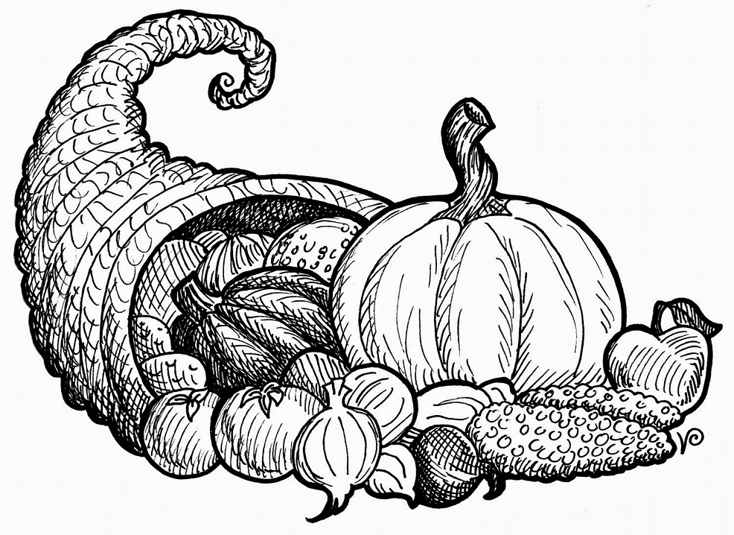
🙚🙚 ❖ 🙙🙙
The beautifully decorated cornucopia that graces the chancel this morning is given in gratitude and love for the many blessings of our church’s family.

Adapted from Prayers for Stewardship from UCC Worship Ways https://www.ucc.org/worship-way/worship_worship-ways_year-b_p_pentecost-ordinary-time-4/

