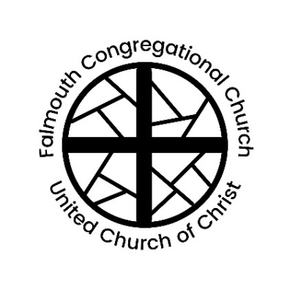
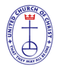
Falmouth Congregational Church
United Church of Christ
Serving Christ and Community since 1754
An Open and Affirming Congregation
The Reverend Amelia Edson
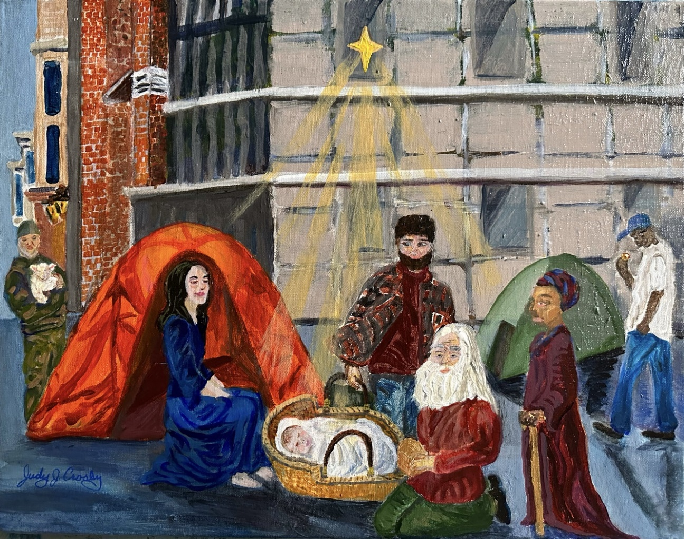
Settled Pastor & Teacher

Advent I: Make Room

267 Falmouth Rd., Falmouth, ME, 04105 | 207-781-3413 | www.falmouthcongregationalchurch.org

10:00 AM FIRST SUNDAY OF ADVENT December 3, 2023

THE COMMUNITY GATHERS
Welcome! If you would like more information about our community, please fill out a blue visitor card. Throughout the order of worship, if the print is in bold, words may be spoken in unison.

GATHERING MUSIC

WELCOME & ANNOUNCEMENTS

THE PASSING OF THE PEACE
One: May the peace of Christ be with you.
All: And also with you.

PRELUDE “Let All Mortal Flesh Keep Silence” Judith E. Treisback
Bell Choir

MAKE ROOM (Video)

*PROCESSIONAL “Lift Up Your Heads, O Mighty Gates” No. 129

CALL TO WORSHIP & LIGHTING OF THE ADVENT CANDLE Pastor Amelia
CHORAL INTRODUCTION

CALL TO WORSHIP
One: We begin the Advent season by yearning for Christ
All: We wait upon the Lord and place our hope in God’s work
One: We survey our lives and strive to make room for Christ’s coming
All: We wait upon the Lord and place our hope in God’s work
One: We confront the division, doubt, and distraction that separates us
All: We wait upon the Lord and place our hope in God’s work
One: This Advent season we choose hope, and prepare the way for the Lord
All: We wait upon the Lord and place our hope in God’s work
LIGHTING OF THE HOPE CANDLE

CONGREGATIONAL SUNG RESPONSE See screen

PRAYER OF CONFESSION Lydia Hoffman
One: When Mary was with child the world viewed her with suspicion.
All: We admit that we, too, struggle to believe other’s truths, and even silence the knowledge of our own hearts.
One: As Joseph and Mary searched for a place to shelter the world closed its doors.
All: We confess that we, too, close ourselves off from the suffering of this world, choosing apathy over empathy and ignorance over engagement.
One: When Jesus was born the powerful attacked his family, trying to stamp out the hope he promised.
All: We realize that we, too, participate in systems that oppress the vulnerable. We, too, are afraid to fully embrace the hope that God offers us.
One: Emmanuel, God with us, forgive us our trespasses and open our hearts.
All: So that on Christmas Day we will be ready to receive you in our midst, and our lives may be testaments of the Christmas Story.

ASSURANCE OF PARDON Lydia Hoffman
One: Let us remember: Christ came to earth so that we might remember our true selves and God’s love.
All: There is nothing we can do, think, or say that can separate us from God in Christ Jesus.
One: Hallelujah!

*HYMN “Come, O Long Expected Jesus” No. 125

SCRIPTURE Isaiah 2:1-5 Grace Howison
Mark 13:24-37 Emily Pond

SERMON “Make Room” Rev. Amelia Edson

*HYMN “Emmanuel, Emmanuel” No. 134
Ushers will collect prayer cards during this hymn.
THE FEAST OF THE LORD’S SUPPER

PREFACE
One: Lift up your hearts.
All: We lift them up to God.
One: Let us give thanks to the Lord our God.
All: It is right to offer thanks and praise.

PRAYER OF THANKSGIVING

RETELLING THE STORY

THE SHARING OF THE BREAD AND CUP

THE SUNG LORD’S PRAYER No. 307

OFFERING OUR GIFTS & FOOD
“O Come, O Come Emmanuel” arr. Lloyd Larsen
Ann Sanborn, saxophone
You may also donate online or on Venmo @FalmouthUCC

*DOXOLOGY No. 46

*BENEDICTION

ORGAN POSTLUDE “Angels from the Realms of Glory” arr. John Innes

† Musical material is presented under CCLI License #11176026
* Please stand in body or spirit

We strive to use a diversity of language to describe God, in line with the diversity of images and metaphors in our Scripture. Many hymns and prayers default to male language. Please use the language that allows you to worship best, knowing that all human speech about God is metaphoric and ultimately incomplete.

Thank you to our worship participants:
Presiding: Rev. Amelia Edson
Minister of Music: Jan Stover
Minister of Children & Families: Lydia Hoffman
Ushers: Caroline Pond, Kim Hendry
Acolyte: Caroline Pond
Advent Candle Lighters: The Boyd Family
Online Worship: Virginia Eddy, Tom Stegemann, Jack Gervais

