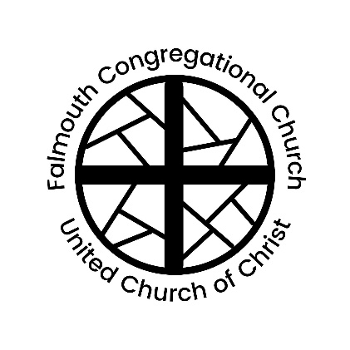
Falmouth Congregational Church
United Church of Christ
An Open and Affirming Congregation
The Reverend Amelia Edson
Serving Christ and Community since 1754
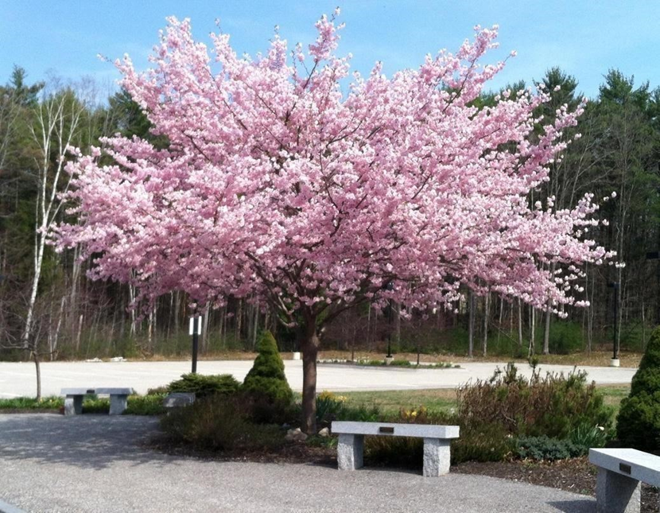

267 Falmouth Rd, Falmouth, ME, 04105 | 207-781-3413 | www.falmouthcongregationalchurch.org

10:00 AM THIRTEENTH SUNDAY AFTER PENTECOST September 4, 2022
THE COMMUNITY GATHERS
If you are new to worship, welcome and please fill out a blue visitor card.
Throughout the order of worship, if print is in bold, words may be spoken in unison.

GATHERING MUSIC

WELCOME & ANNOUNCEMENTS

THE PASSING OF THE PEACE (Please remain in your seat while passing the peace of Christ.)
One May the peace of Christ be with you.
All: And also with you.

PRELUDE “Meditation” Jules Massenet
Ann Sanborn, Saxophone and Jan Stover, Piano

CALL TO WORSHIP
One: We lift our eyes to the hills – from where will our help come?
All: Our help comes from the Holy One, who made heaven and earth.
One: The Beloved will not let your foot be moved; the One who keeps you will not slumber.
All: The Holy One is our keeper, and our shade at our right hand.
One: The Beloved will keep you from all evil, God will keep your life.
All: God will keep our going out and our coming in, from this time on and forevermore.
One: Let us release our troubles and worries to God and worship together.

CALL TO CONFESSION & ASSURANCE OF PARDON
(Adapted from the Lord’s Prayer)
One: Forgive us our debts, Lord God,
All: As we ourselves forgive those indebted to us.
One: Help us to acknowledge our own imperfection,
All: And from that knowledge love and forgive the world.
One: Give us the audacity to try again and again.
~
All: The compassion of the Lord is from everlasting to everlasting.
One: God’s mercy is new every morning,
All: Great is God’s faithfulness.
One: Let us believe the good news of the gospel.
All: In Jesus Christ we are forgiven. Amen.

CHILDREN’S MOMENT Hannah Daly
*HYMN “God Is Here!” #280

SCRIPTURE Luke 12:22-31 Ann Sanborn

THE SERMON Don’t Worry, Be Happy Rev. Cheryl Anderson

HYMN “The Lord’s My Shepherd” #78

THE FEAST OF THE LORD’S SUPPER

PREFACE
One: Lift up your hearts.
All: We lift them up to God.
One: Let us give thanks to the Lord our God.
All: It is right to offer thanks and praise.

PRAYER OF THANKSGIVING

RETELLING THE STORY

THE SHARING OF THE BREAD AND CUP

THE LORD’S PRAYER (Sung) #307
OFFERING OUR GIFTS TO GOD

*HYMN “I Will Sing of the Mercies of the Lord” #87

BENEDICTION

BENEDICTION RESPONSE “Go in Peace” #445

ORGAN POSTLUDE “Finale – from Concerto No. 5” G.F. Handel

* Musical material is presented under CCLI License #1117602

*Please stand in body or spirit

Thank you to our worship participants:
Presiding: Rev. Cheryl Anderson
Minster of Music: Jan Stover
Ushers: Mark and Peggy Horton
Liturgist: Ann Sanborn
Online Worship: Virginia Eddy, Tom Stegemann, Jack Gervais

🙚🙚 ❖ 🙙🙙

Next Sunday’s Lectionary
Jeremiah 4:11-12, 22-28; Psalm 14; 1 Timothy 2:12-17; Luke 15:1-10

The Chancel flowers are given today by Graham Harriman
In loving memory of
Juana Medina Michel and
Ann Rees Harriman
If you’d like to learn more about our church, sign up for our weekly email,
or contact our staff please visit our website at
www.falmouthcongregationalchurch.org or call (207)781-3413.

Adapted from Psalm 121

